Critical Illness Trust and Pool Cancer Claim Form

A claim is being filed for the covered cancer type below:
☐Skin | ☐Melanoma | ☐Colon | ☐Rectal | ☐Esophagus | ☐Stomach | ☐Bladder
☐ Prostate | ☐ Brain | ☐ Myeloma | ☐ Non-Hodgkins | ☐ Breast | ☐ Lung | ☐ Testicular
☐ Mesothelioma | ☐ Thyroid | ☐ Kidney | ☐ Ovarian | ☐ Cervical | ☐ Pancreas | ☐ Leukemia
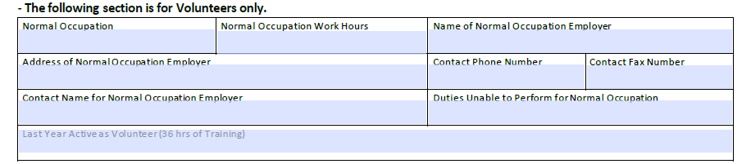
Description of the severity of the cancer, including the current cancer stage:
Body Part | Click or tap here to enter text.
Cancer Type | Click or tap here to enter text.
Cancer Stage | Click or tap here to enter text.
Description | Click or tap here to enter text.

SECTION 1 – To Be Completed by Covered Individual
The Covered Individual must attest that the eligibility for benefits under this program have been met by certifying the following:
- Is an active full-time (FT), part-time (PT), volunteer (Vol), or retired (Ret) employee of the department: ☐FT ☐PT ☐VOL ☐Ret
- Has been assigned to at least five years as a firefighter; was last assigned to duty as a firefighter within the last fifteen years; and is not seventy years of age or older at the time of diagnosis: ☐ Yes ☐ No
- Was listed on the census filed with the MFFCIP: ☐ Yes ☐ No *if no, explain ________________________________________
- Performs duties that are directly involved with the provision of fire protection services: ☐ Yes ☐ No
- Had medical exam that could have reasonably found cancer at time of employment, prior to diagnosis ☐ Yes ☐ No ☐Unk
- Has not smoked , chewed, used or consumed tobacco at any time in the past 5 years: ☐ True ☐ False

*Please attach a copy of the physician’s diagnosis and the last medical examination record to this claim form.

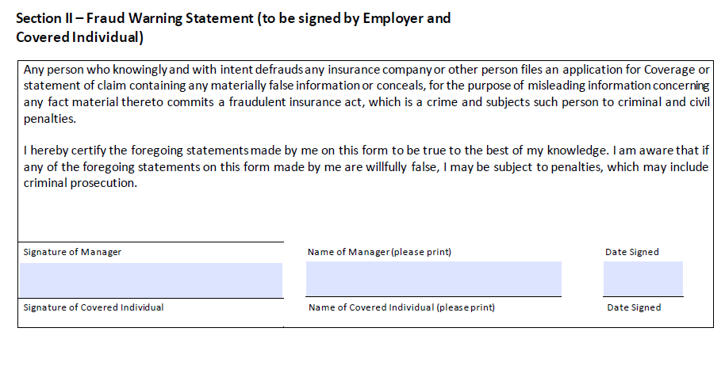

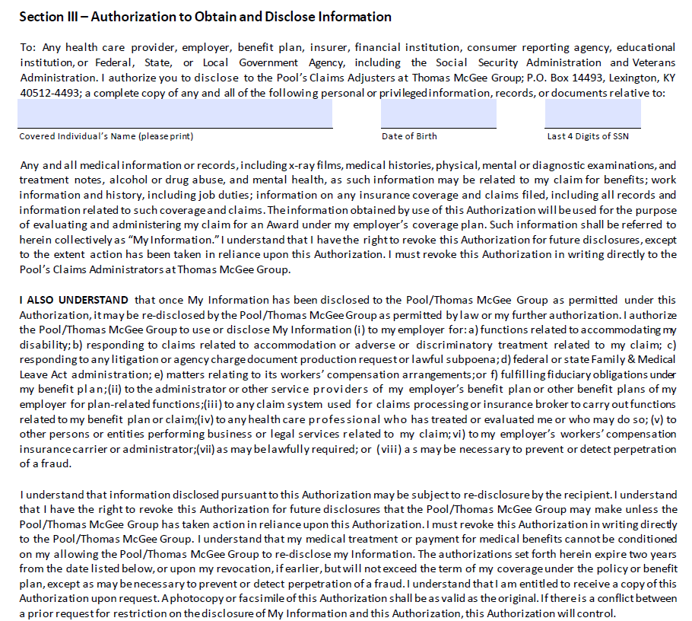
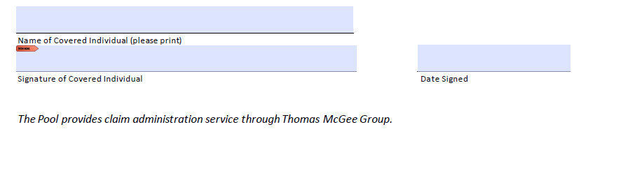
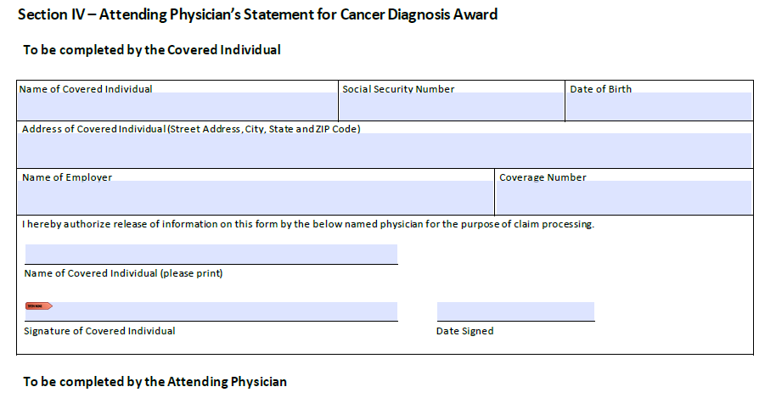
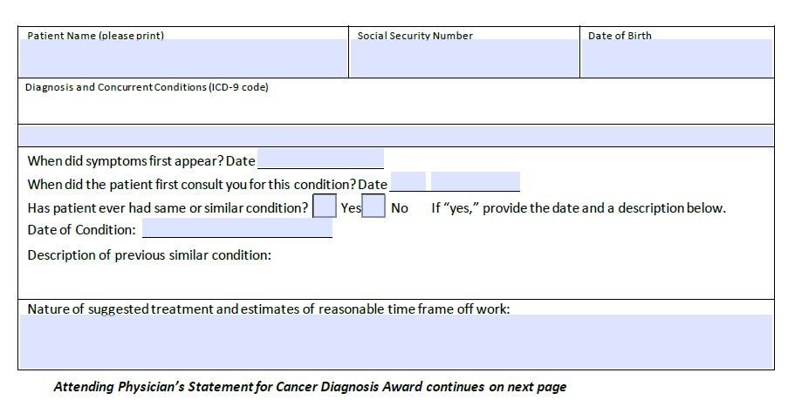

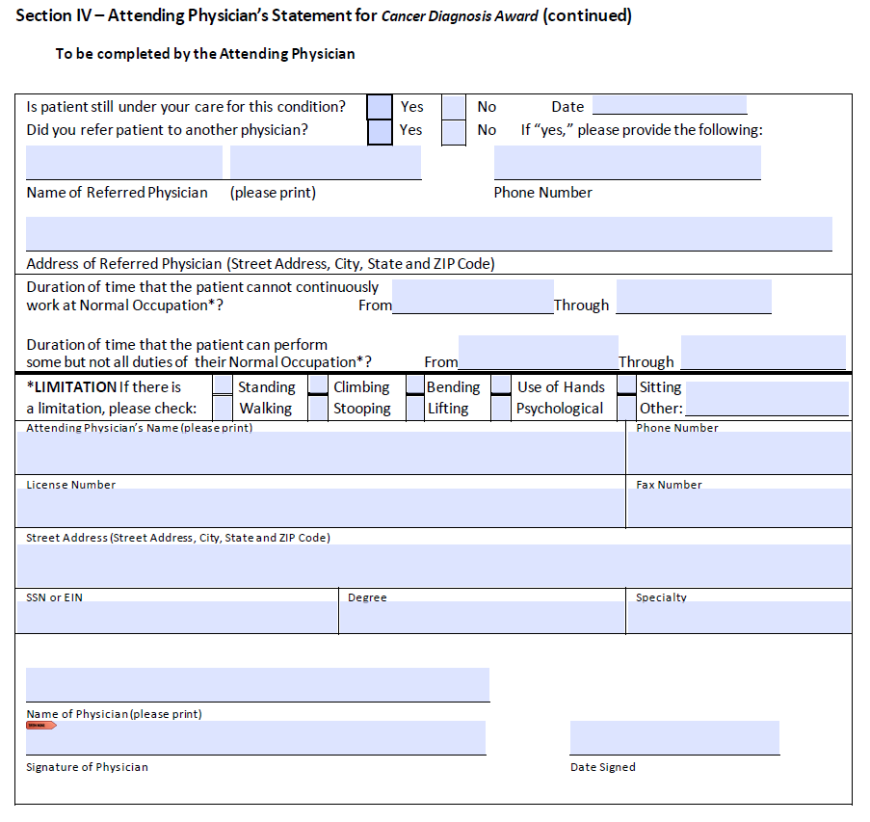
SECTION V – Designation of Beneficiary
Beneficiary may be a spouse, domestic partner or legal dependent:
- Name of Beneficiary: Click or tap here to enter text.
- Phone Number of Beneficiary: Click or tap here to enter text.
- Email for Beneficiary: Click or tap here to enter text.

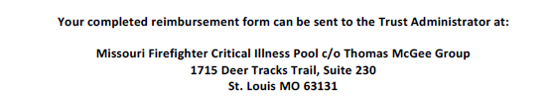
Or Email: mffcip@thomasmcgee.com

